|  |  |  |  |  |
| --- | --- | --- | --- | --- |
|  | **Count Vectors** | **WordLevel TF-IDF** | **N-Gram Vectors** | **Character Level** |
| **Random Forest** | 0.867 | 0.90 | 0.848 | 0.937 |

**Table 1:** Accuracy of the classification model for various features

|  |  |  |
| --- | --- | --- |
| **Model** | **Recall (Weighted Average)** | **Precision (Weighted Average)** |
| RandomForest (Count Vectors) | 0.89 | 0.87 |
| RandomForest (Word Level TF-IDF) | 0.92 | 0.90 |
| RandomForest (N-gram TF-IDF) | 0.86 | 0.85 |
| RandomForest (Character Level TF-IDF) | 0.94 | 0.94 |

**Table 2:** Weighted Average Recall and Precision of the Models.

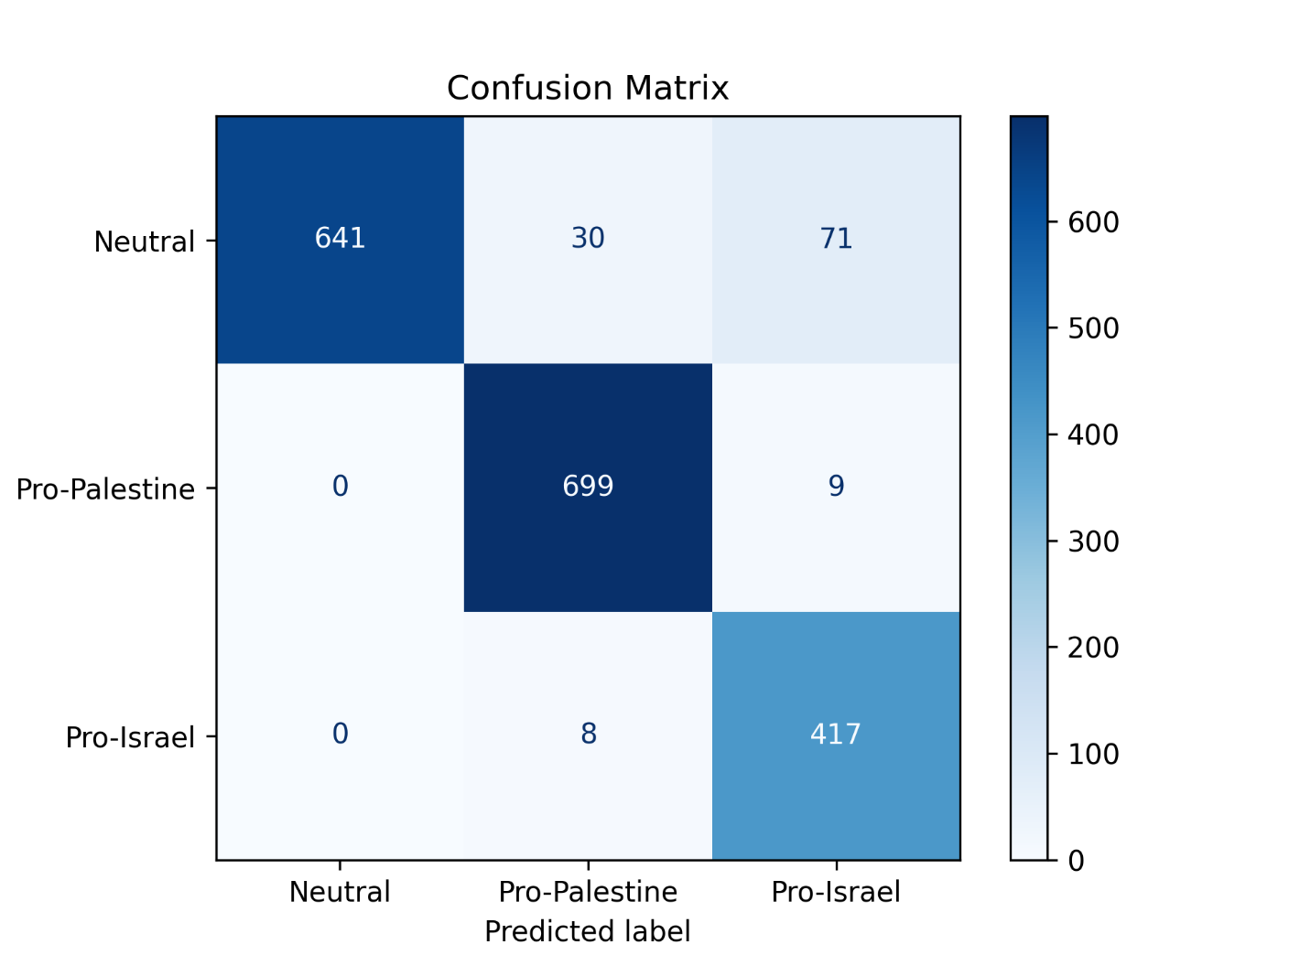

**Fig-1:** Confusion Matrix of the selected model (Char-level RF)